University of Petroleum and Energy Studies
School of Computer Science
Department of Cybernetics

Graphics & Animation Tools
LAB FILE
(Session: 2020-2021)

Course: B. Tech with Specialization in Open Source and Open Standards

Submitted To- Submitted By-
Dr. Durgansh Sharma Rahul Raj Baranwal
Associate Professor SAP ID -500061624
Department of Cybernetics Roll No. -R100217054

Experiments -1 Design of 3D Rocket using Blender.
In this experiment we need to create a 3D Rocket of our choice with the help of blender.

Steps to follow to create a 3D Rocket using Blender
- Clear your default interface of blender which includes deletion of cube.
- Now press Shift+A, go to mesh and select a cone and change it’s vertices to 12 (Standard is 32)
- Now scale down 0.5 and drag it up towards z-axis. Now press tab, select edit-mode and select face select mode. After that select bottom face and extrude it along z-axis. Now extrude a little bit more and press S to scale mode. Scale it down it face so that it’s face looks a little bit bigger.
- Extrude one more time and this time double to the length of previous extrude.
- Now, we need to calculate create the fin our rocket. For that, select every 3rd section out of 12 sections of the bottom of the rocket, now extrude all 4 sections about 0.7.
- Now, give your fins a look of aero-dynamic shape by scaling it down a bit (0.4)
- And last part of modelling of rocket, extrude the bottom of rocket and extrude one more time and right click and select appropriate vertices and scale it down a bit. And finally extrude it upwards, which will actually provide your rocket the look for flames and exhaustion area of rocket.
- Now for the colouring part, go into the edit mode again, and select the faces you want for one colour, and click the + button in the materials section
- This will apply the colour to all faces, next click on another face, click the + button, and click Assign, this will give the selected face the new material.
- Finally export your files as .blend file and also render a few images for the reference purpose.

Output (Rendered Images of Our Rocket)

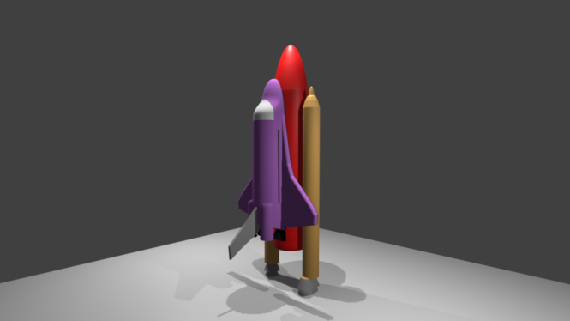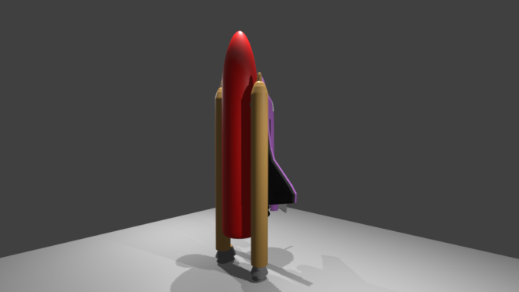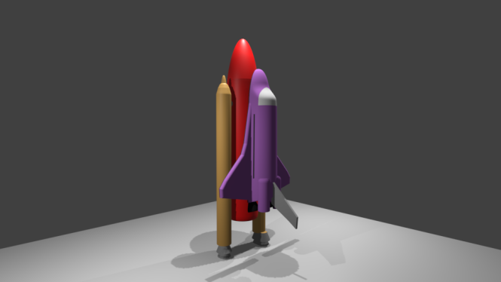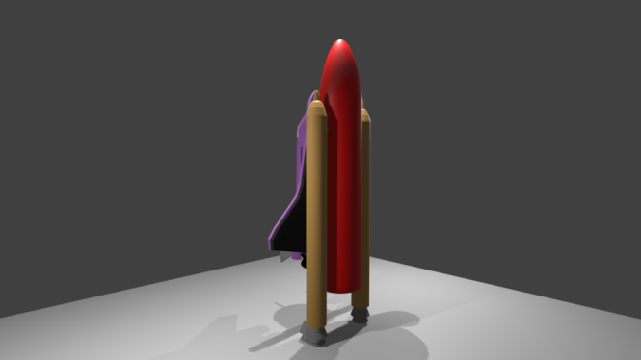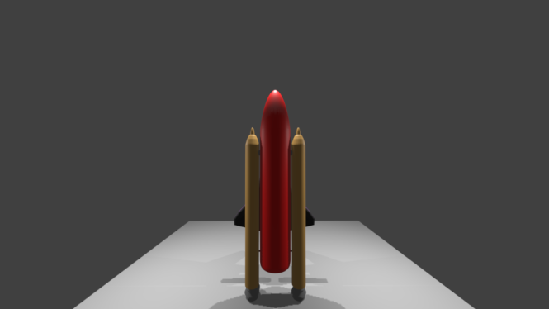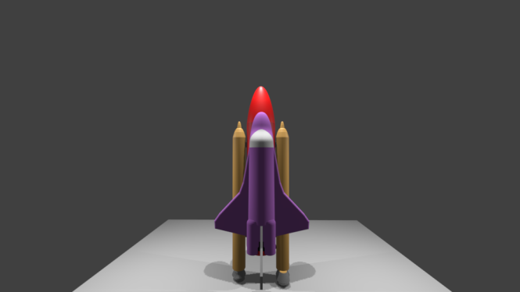

Link of the experiment files:

